HHOOWW
KKEEVVLLAARR
DDIIFFFFEERRSS


FFRROOMM OOTTHHEERR
SSYYNNTTHHEETTIICC FFIIBBEE

 Kevlar is a high-performance synthetic fiber known for extraordinary tensile
What is kevlar?
strength, thermal stability, and impact resistance.It belongs to the aramid (aromatic polyamide) family — polymers containing amide linkages (-CONH-) attached to
aromatic rings.
Molecular structure:[-CO–C₆H₄–CO–NH–C₆H₄–NH-]n
 Strong intermolecular hydrogen bonds and π–π stacking between benzene rings give Kevlar its rigidity and high crystallinity.
Brief history
 Discovered in 1965 by Stephanie Kwolek, a polymer chemist at DuPont.  Commercially introduced in 1971 by DuPont.
 Originally developed for lightweight, high-strength tire reinforcement.
 L ater adopted in aerospace, military, and safety equipment due to its exceptional mechanical properties.

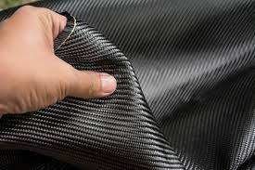
Kevlar Fibre

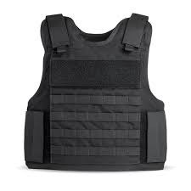
Bullet Proof kevlar:



Chemical Reaction for Synthesis
p-Phenylenediamine (PPD) → NH₂–C₆H₄–NH₂ Terephthaloyl chloride (TCl) → Cl–CO–C₆H₄–CO–Cl
Reaction:
nNH₂–C₆H₄–NH₂+nCl–CO–C₆H₄–CO–Cl→[−CO–C6H4–CO–NH–C6H4–NH−]n+2
 Kevlar’s backbone contains benzene rings positioned in the para (1,4-) orientation.
 In para-aramids, the amide groups (-CONH-) are attached to opposite ends of the benzene ring (at positions 1 and 4).
 This linear alignment allows the polymer chains to be highly oriented and closely packed, forming a crystalline structure.
 This structural orientation contributes to:  High tensile strength
 Low elongation,thermal stability.

Manufacturing process of kevlar

Step1: Polymerization
Chemical reaction:
p-Phenylenediamine (PPD) + Terephthaloyl chloride (TCl) → Poly(p- phenylene terephthalamide) + HCl
Type: Step-growth condensation polymerization

 Conditions:Conducted in
Aa dpdolaarliattplreobtiict osof lbvoendtystuecxht
as N-methylpyrrolidone (NMP)

 Low temperature (~0–10°C)
 Product: Poly(p-phenylene terephthalamide) (Kevlar polymer)

Step2: Spinning
The polymer is dissolved in concentrated sulfuric acid (H₂SO₄) to form a liquid crystalline solution.



This solution is extruded through a spinneret into a coagulation bath, forming fine filaments. Process type: Wet spinning

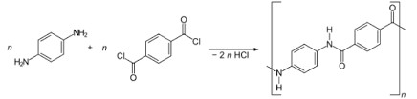

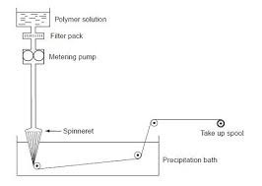
Polymerization Reaction

Wet spinning process:

Continuation....

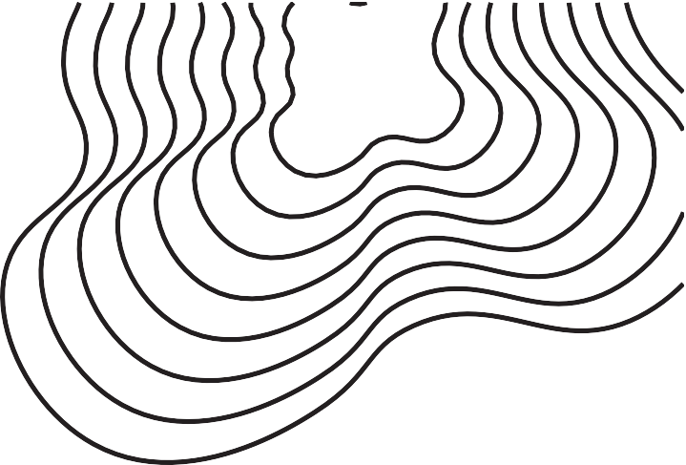
Step 3: Drawing (Orientation & Crystallization):
 The spun fibers are drawn (stretched) to several times their original length.  This aligns the para-oriented polymer chains along the fiber axis.
Results in:
 High crystallinity
 Strong inter-chain hydrogen bonding
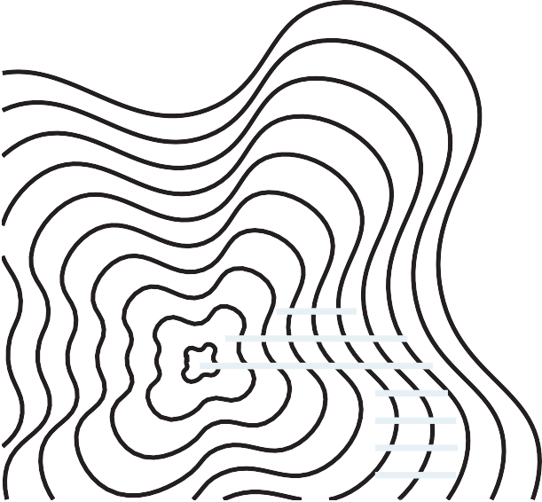
 Enhanced tensile strength and modulus

Introduction to synthetic polymers
Definition: Man-made fibers produced from chemical substances (usually polymers). Examples
Nylon – used in ropes, fabrics, and stockings. Polyester – used in clothing and home furnishings.
Acrylic – used as a wool substitute in sweaters and blankets.
Kevlar (Aramid) – used in body armor, ropes, and aerospace materials.
General properties: lightweight, durable, resistant to moisture, versatile.
General Properties:
 Lightweight yet strong.
 Durable and resistant to wear and tear.
 Resistant to moisture, mildew, and chemicals.
 Elastic and versatile — easy to dye and maintain.  Often less expensive than natural fibers.

Synthetic polymers examples:

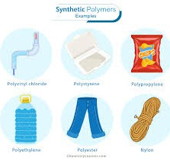
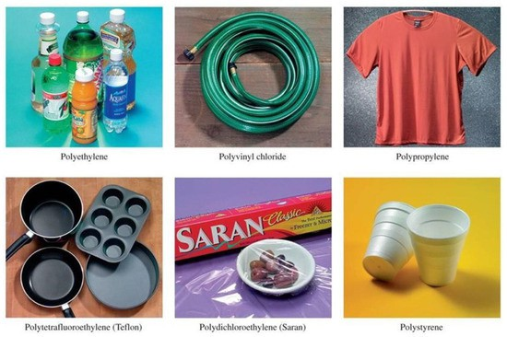

Common Synthetic Fibers for Comparison
Factor
Cost Dyeability

UV Resistance Processing
Use Cases
Kevlar
Expensive to produce (complex polymerization & spinning process)
Difficult to dye due to rigid molecular structure
Degrades under prolonged UV exposure
Requires specialized equipment and high-precision control
High-strength applications (armor, aerospace, protective
gear)
Other Synthetic Fibers (e.g.,
Nylon, Polyester)
Much cheaper and easier to manufacture

Easy to dye and color
Better UV stability (varies by fiber)
Easier to process and widely supported

General clothing, packaging, everyday textiles

Kevlar (Aramid)
Structural difference
Contains para-oriented benzene rings in its backbone (substituted at positions 1 and 4). The chains are linear and rigid, leading to high alignment and crystallinity.
Strong intermolecular hydrogen bonding between –NH and C=O groups holds chains tightly together.
Result: High tensile strength, thermal stability, and low elasticity.
Nylon and Polyester
Have aliphatic or partially aromatic structures, making them more flexible and less crystalline. Nylon contains –(CH₂)n– segments between amide groups → allows chain mobility.
Polyester (e.g., PET) has –O–CH₂–CH₂–O– linkages → adds flexibility and smooth texture. Result: More elastic, less rigid, and lower melting points compared to Kevlar.
Structural Consequence
Kevlar’s para-structure → tight packing, strong hydrogen bonding, and high crystallinity.
Nylon & Polyester’s aliphatic segments → weaker inter-chain forces, lower crystallinity, and greater flexibility.



Bonding and Intermolecular Forces
kevlar (Aramid Fiber)
Strong Intermolecular Hydrogen Bonds
Between amide hydrogen (–NH–) and carbonyl oxygen (–CO–) of adjacent chains.
 These bonds form a dense network that locks the polymer chains together.  Result: High tensile strength, thermal stability, and low elongation.
 Example bond representation:
 –CO–NH⋅⋅⋅O=C–NH––CO–NH···O=C–NH––CO–NH⋅⋅⋅O=C–NH–
 π–π Stacking Between Aromatic Rings

 The benzene rings in the para orientation stack through π–π interactions, adding rigidity and enhancing crystallinity.
 This stacking stabilizes the fiber alignment along the polymer axis.
 Combined Effect:

→ Tightly packed, highly ordered molecular structure → exceptional mechanical strength.


Continuation....

Other Synthetic Fibers (e.g., Nylon, Polyester)
Weaker Intermolecular Forces
Mostly Van der Waals interactions and occasional hydrogen bonds (less extensive than Kevlar).
 Flexible aliphatic segments interrupt close chain packing.
Result:
 Lower tensile strength, greater flexibility, and lower melting point.
n
N H
n
 Less chain alignment → lower crystallinity.
O

H N

Nylon
H N
O
O

Mechanical and thermal properties:
Property

Tensile Strength (GPa)

Density (g/cm³)

Melting Point (°C)

Elasticity

Notable Traits
Kevlar

3.6

1.44

~500
(decomposes)

Low

Extremely strong, heat-resistant
Nylon

0.9

1.15

250

High

Durable, elastic
Polyester

0.6

1.38

260

Moderate

Weather & UV resistant
Acrylic

0.3

1.17

230

Moderate

Warm, wool-like
Polypropylene (PP)

0.3

0.90 (very low)

160

Low–Moderate

Lightest fiber, floats
UHMWPE
(Dyneema/Spectra
)

3.0–4.0

0.97

130–150

Low

Stronger than steel by weight
Rayon (Viscose)

0.4

1.5

150–200 (depends on type)

Moderate–High

Soft, absorbent


Mechanical and thermal properties:

Key observatinos:
Kevlar shows exceptionally high tensile strength and thermal stability,
making it ideal for high-performance applications.
 Nylon and Polyester are more flexible and elastic, suitable for textiles and consumer goods.
 Acrylic offers softness and warmth, used mainly as a wool substitute.
 The difference in molecular structure and bonding explains these property variations:
 Kevlar → strong H-bonds + π–π stacking → high strength, low elasticity.  Nylon/Polyester → more flexible aliphatic segments → higher elasticity.
1.

Functional differences and Applications

Fiber | Major Uses | Why / Key Property
Kevlar (Aramid) | Bulletproof vests, helmets, tires, aerospace | Extremely high tensile strength and heat resistance
Nylon (Polyamide) | Parachutes, ropes, seat belts, fabrics | Excellent elasticity and abrasion resistance
Polyester (PET) | Clothing, PET bottles, home furnishings | High chemical resistance, wrinkle-free, durable
Acrylic (PAN-based) | Sweaters, carpets, upholstery | Soft, warm, colorfast, wool-like feel
Spandex (Elastane / Lycra) | Sportswear, leggings, swimsuits | Exceptional elastic recovery and stretchability
Polypropylene (PP) | Thermal wear, packaging, ropes, carpets | Very lightweight, moisture-resistant, and inexpensive
Polyethylene (PE) | Fishing lines, plastic films, fibers | Good chemical resistance and flexibility
Rayon (Semi-synthetic) | Dresses, upholstery, medical gauze | Soft, absorbent, drapes well (less durable)
Teflon (PTFE) | Non-stick coatings, protective clothing | Excellent chemical and thermal resistance

Chemical and Environmental Resistance of Synthetic Fibers

Kevlar (Aramid)

Excellent resistance to heat, flames, and most chemicals.
 Remains stable under harsh environmental conditions.  Does not melt; decomposes gradually around 500 °C.
 Strong intermolecular hydrogen bonding → prevents deformation.
Other synthetic fibre:
Fiber Nylon
Polyester Acrylic
Polypropylene
Limitation / Weakness

Absorbs water → loses strength Melts at high temperature
Burns easily, poor heat stability

Degrades under UV exposure
Reason / Effect

–CO–NH– groups form hydrogen bonds with water
Thermoplastic nature (softens above ~260 °C) Contains nitrile groups that decompose quickly
Lacks aromatic rings for UV stabilization

Case Study 1: Performance Comparison of Kevlar vs Common Synthetic Fibers
Property
Tensile Strength (GPa) Density (g/cm³) Thermal Stability (°C) Elasticity
Kevlar

3.6

1.44
~500 (decomposes) Low
Nylon

0.9

1.15

250

High
Polyester

0.6

1.38

260

Moderate
Acrylic

0.3

1.17

230

Moderate
PP

0.3

0.9

160

Low–Moderate
UHMWPE 3.0–4.0
0.97

130–150

Low

Case Findings
Kevlar has the highest thermal resistance among all compared fibers.
UHMWPE matches Kevlar in tensile strength but loses significantly in heat resistance.
Nylon and Polyester are versatile, but not suitable for extreme stress or heat. Polypropylene is the lightest, but mechanically weak.
For high-strength protective applications, Kevlar remains the best balance of strength + heat resistance.

Case Study 2: Kevlar vs UHMWPE in Ballistic Helmets

Problem:Defense organizations needed lighter helmets without sacrificing ballistic protection.
Factor
Weight
Heat Resistance Ballistic Resistance Durability
Kevlar Helmet
Heavier
Excellent (up to 500°C) Very high
Excellent
UHMWPE Helmet
40–50% lighter
Poor (softens ~150°C) High (comparable) Moderate

Result
UHMWPE offered lighter helmets, improving soldier mobility. Kevlar offered better heat resistance and durability.
Conclusion
Kevlar is preferred in high-temperature or harsh-environment operations, while UHMWPE fits lightweight tactical missions.

Case Study 3: Kevlar vs Nylon in Motorcycle Protective Gear

Problem:Riders need abrasion-resistant clothing for crashes.
Factor
Abrasion Resistance Heat from sliding Weight
Cost
Kevlar
Very high
Does not melt Light
Higher
Nylon
Moderate
Melts, causing skin burns Light
Lower
Result
Kevlar withstands long abrasion during road sliding. Nylon melts at high friction temperatures.
Conclusion
Kevlar is the safer material for impact zones (knees, elbows), while nylon is used for outer shells.

Case Study 4: Kevlar vs Acrylic in Firefighter Suits

Problem: Firefighters need flame-resistant, durable clothing.
Factor

Flame Resistance Strength
Heat Shrinkage

Application Fit
Kevlar

Excellent (does not melt)

Very high Low
Core structural fabric
Acrylic

Poor to moderate Weak
High

Outer aesthetic fabric

Result
Kevlar maintains structural integrity under flame exposure. Acrylic fails quickly due to melting and shrinking.
Conclusion
Kevlar is mandatory for structural protection layers, while acrylic is unsuitable for fire environments.

Limitations and Cost Factors:
Kevlar – Disadvantages
High production cost due to complex polymerization and spinning processes. Difficult to dye because of its rigid, crystalline molecular structure and strong hydrogen bonding.
Degrades under UV light, losing strength when exposed to sunlight for long periods. Hard to process or cut — very tough, causing wear on machinery and tools.

Other Synthetic Fibers
 Generally cheaper, easier to produce, and more versatile.
 Widely used in textiles and consumer products due to lower cost and simpler dyeing.
 However, they lack the extreme strength and heat resistance of Kevlar.


Conclusion
Kevlar’s unique molecular architecture — featuring para-oriented benzene rings and strong hydrogen bonding — makes it stand out among all synthetic fibers.
 It offers exceptional strength, stiffness, and thermal resistance, enabling
applications from body armor to aerospace materials.
 Despite its high cost and processing challenges, Kevlar remains a symbol of innovation in polymer science.
💬 Key Takeaway
“Kevlar represents the bridge between chemistry and protection.”

Refrences:

DuPont. Kevlar® Aramid Fiber Technical Guide. PDF. Link — contains detailed technical data on Kevlar’s structure, properties, applications. DuPont+1
Stephanie Louise Kwolek. U.S. Patent 3,819,587: Wholly aromatic carbocyclic polyamide fiber. Link — the original inventor’s patent for Kevlar. Google Patents+1
Materials Science and Engineering: An Introduction by William D. Callister Jr. (and D. G. Rethwisch). 8th ed., John Wiley & Sons. (Cited in literature on polymer/aramid fiber structure) ResearchGate+1
Wikipedia article: Kevlar. Link — good general background on Kevlar’s development, properties, uses. Wikipedia+1
ScienceDirect article: Investigation on mechanical behavior of woven fabric glass/Kevlar hybrid composite laminates… A. Srivathsan et al., 2017. Link — useful for applications/comparison of Kevlar in composites. ScienceDirect+1
Another datasheet: Kevlar® Para-Aramid – Fiber-Line® (Manufacturer summary PDF). Link — gives composition and key features of Kevlar. FIBER-LINE®
Additional references you might consider adding:
Scholarly paper: Paracrystallinity-modulus relationships in Kevlar aramid fibers. Barton et al., 1985. Link via Semantic Scholar Semantic Scholar
Journal on composite materials / fibers: e.g., “Short fiber reinforced composites” chapter (Wiley, 2022) for context of synthetic fibers. Link onlinelibrary .wiley .com

Refrences:
Case Study 2: Kevlar vs UHMWPE in Ballistic Helmets
NIJ (National Institute of Justice) – Ballistic Resistance of Body Armor, NIJ Standard 0101.06. Honeywell Spectra® Technical Data Sheet, Honeywell Advanced Materials.
DuPont Kevlar® Technical Guide, DuPont Safety & Construction.
Marissen, R., “Design of UHMWPE Helmets for Ballistic Protection,” Composite Structures, Elsevier.
Baran, I., “Comparison of Aramid and UHMWPE Composites in Impact Applications,” Materials Today Proceedings.
Case Study 3: Kevlar vs Nylon in Motorcycle Protective Gear
ECE R-135 & R-22.05 Standards – Protective Clothing for Motorcyclists, UNECE.
K.J. Kim et al., “Abrasion Resistance of Aramid vs Nylon Fabrics,” Journal of Industrial Textiles. DuPont, “Kevlar for Motorcycle Protection” (Application Guide).
“Thermal Damage to Synthetic Fibers During Motorcycle Slides,” Accident Analysis & Prevention. Case Study 4: Kevlar vs Acrylic in Firefighting Suits
NFPA 1971 Standard – Protective Ensembles for Structural Fire Fighting. Dupont™ Nomex & Kevlar Firefighter Gear Technical Specification.
A. Horrocks, “Flame Retardant Textile Fibers,” Woodhead Textiles Series.
S. Mandlekar et al., “Thermal Degradation of Acrylic vs Aramid Fibers,” Polymer Degradation and Stability.


TTHHYYOOAANNUUKK

